**English Title Will Be Here (Times New Roman Font / 12 Point, Bold / Only Initials Should Be Uppercase / Max. 12 Words.)**

Author Name Surname1, Author Name Surname2, Author Name Surname3 (Times New Roman Font, 8 Point)

***Abstract (150-250 Words, Bold)***

*(The summary text should be written with 1 line spacing, and there should be no spaces before and after the paragraph. There should be no indentation in the text.* *Abstract, in Times New Roman font, italic and 10 point font.)*

*Today, the development and widespread use of technology has brought about many structural changes. In the pioneer of the development of the Internet network and the software architecture, a decentralized environment can be created with the principle of co-work. In this sense, without a specific center, we can talk about a new technology with a model of communication between spouses, cryptographic data and a distributed system structure. In fact, similar applications have emerged in the past, but the block chain has done different things. In particular, the widespread use of cryptographic money has changed the perspective of financial systems.*

***Keywords—*** Block Chain, Crypto Money, Business Practices (Max 4 words / Every word must start with a capital letter).

**Full Text:** It should be between 5000-6500 words, excluding references. The margins should be equal, 2.5 cm for the right, left, top and bottom sections. The font should be Times New Roman and the font size should be 11 points.

**1. Introduction** **(Only Initials Are Uppercase / 11 Point / Times New Roman Font / Bold)**

In this section, the first line should start 0.5 cm inside. Paragraph spacing should be 0 pt first and then 6 pt. The entire paragraph should be written in single-line spacing. References in the entire text should be as shown in the examples. (Beck et al. 2016) or (Beck, 2016:8)

**2. Conceptual framework / Theoretical Framework / Related Literature (Only Initials Are Uppercase / 11 Point / Times New Roman Font / Bold)**

In this section, the first line should start 0.5 cm inside. Paragraph spacing should be 0 pt first and then 6 pt. The entire paragraph should be written in single-line spacing. References in the entire text should be as shown in the examples. (Beck et al. 2016) or (Beck, 2016:8)

The reference to the figure example to be given in the text should be aligned to the left and placed below the figure. The shape name should be above the shape and centered. Tables or figures must be cited in the text.

Figure 1: Only Initials Are Uppercase / 11 Point / Times New Roman

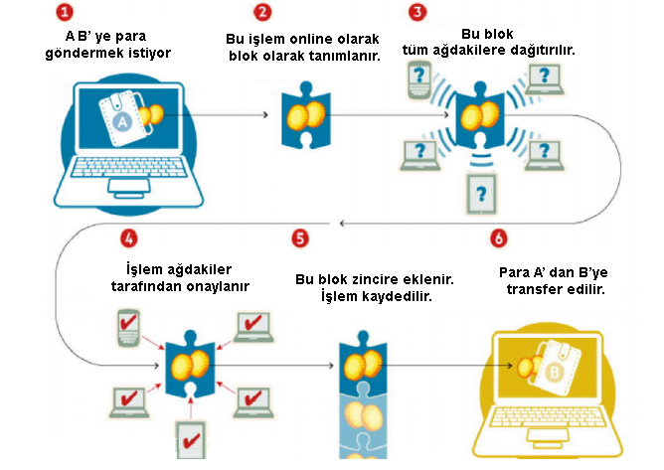

Source: Crosby, 2016

**2.1.** **Subtitle**

In this section, the first line should start 0.5 cm inside. Paragraph spacing should be 0 pt first and then 6 pt. The entire paragraph should be written in single-line spacing. References in the entire text should be as shown in the examples. (Beck et al. 2016) or (Beck, 2020:8).

The reference to the table example to be given in the text should be left aligned and placed below the table. The name of the table should be above and centered. Tables or figures must be cited in the text.

Table 1: Only Initials Are Uppercase / 11 Point / Times New Roman Font

|  |  |  |
| --- | --- | --- |
| xxxxx | xxx | xxx |
| x | x | x |
| x | x | x |
| x | x | x |
| x | x | x |

Source: Tian, 2016.

Table content must be 1 line apart. 8-10 point range can be used. Only internal horizontal lines should be included.

**3. Method**

In this section, the universe, sample, assumptions, original value, economic, social and scientific contribution and limitations of the research should be included.

In this section, the first line should start 0.5 cm inside. Paragraph spacing should be 0 pt first and then 6 pt. The entire paragraph should be written in single line spacing. References in the entire text should be as shown in the examples. (Beck et al. 2016) or (Beck, 2020:8).

**4. Findings**

In this section, the first line should start 0.5 cm inside. Paragraph spacing should be 0 pt first and then 6 pt. The entire paragraph should be written in single line spacing. References in the entire text should be as shown in the examples. (Beck et al. 2016) or (Beck, 2020:8).

**5. Discussion**

In this section, the first line should start 0.5 cm inside. Paragraph spacing should be 0 pt first and then 6 pt. The entire paragraph should be written in single line spacing. References in the entire text should be as shown in the examples. (Beck et al. 2016) or (Beck, 2020:8).

**6. Conclusion**

In this section, the first line should start 0.5 cm inside. Paragraph spacing should be 0 pt first and then 6 pt. The entire paragraph should be written in single line spacing. References in the entire text should be as shown in the examples. (Beck et al. 2016) or (Beck, 2016:8)

**Referances**

Kuo, T. C. (2003). Green product development in quality function deployment by using fuzzy logic analysis, *IEEE International Symposium on Electronics and the Environment*, 88-93.

Kutay, N., Tükenmez, M., & Akkaya, G. C. (2005). Creative accounting: In the view of ethics past experiences and future perspectives, *AACF 2nd Annual International Accounting Conference*, İstanbul, 10-12.

Lewis, M. A. (2000). Lean production and sustainable competitive advantage. *International Journal of Operations & Production Management*, 20(8), 959-978.

Long, D. (2012). Uluslararası lojistik küresel tedarik zinciri yönetimi, (Çev. M. Tanyaş & M. Düzgün), Nobel Akademik Yayıncılık, Ankara.

Russell, R. S. & Taylor, B. W. (2011). Operations managament, John Wiley & Sons Inc, USA.

T.C Sayıştay Bakanlığı (2022). 2022 yılı kamu işletmeleri genel raporu . https://www.sayistay.gov.tr/reports/category/8-kamu-isletmeleri-genel-raporlari, Erişim Tarihi: XX.XX.XXXX.

Yüksel, H. (2013). Application of theory of constraints’ thinking processes in a reverse logistics process, reverse supply chains ıssues and analysis, (Ed. S.M.Gupta), Taylor & Francis Group CRC Press, USA, 22-26.